**Inventory Module – Solved:**

Christy’s newest client has a golden retriever with ear problems. After looking into the issue, Christy has realized that many ear problems are easily dealt with during grooming and has decided to include treating basic ear conditions as part of her services. She purchases ear cleaner and adds the bottles to her grooming supplies, which includes a variety of shampoos and conditioners.

A common question asked by clients is ‘what ingredients are in the products that she uses?’ as some of her clients are concerned about their pet’s allergies and other additives, and Christy would like to be able to quickly access this information.

While Christy would prefer to purchase her grooming products from Amazon, this requires some planning ahead of time, which she’s not always organized enough to do. More often than not, she ends up at Ren’s Depot or even Wal-Mart, buying as she needs to. Christy realizes that products will be cheaper if she purchases ahead of time and looks for deals, or buys in bulk.

Christy would like a system that helps her organize her purchases, instead of having to look through a combination of online orders and paper receipts. She would like the ability to attach a copy or picture of the receipt to the purchase order for tax and tracking purposes.

**Class Diagram**

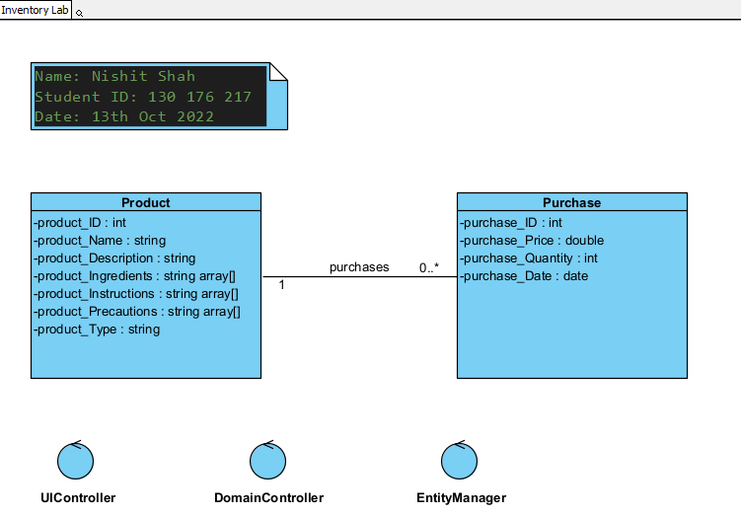

-purchase_Supplier : string

**Use Case: Maintain Product**

User Story

As the owner of this business, I would like to record the products that I use for easy information retrieval. I want to be able to quickly show my customers the ingredients in the products. I don’t expect that I’ll have to retrieve products by their ingredients.

Acceptance Criteria:

1. Must be able to record critical information about each product.
2. Allow deletion of products, in case the owner makes a mistake. Owner must be prompted to confirm and product must not be included in any purchase orders.
3. Must be able to easily retrieve product information including ingredients and precautions for use.
4. Must be able to retrieve a list of products by product type, so that the owner can retrieve all shampoo products, conditioner products, etc.

|  |  |  |  |
| --- | --- | --- | --- |
| Use Case Name | Add New Product | | |
| Triggering Event | A new product of interest to the business to eventually order | | |
| Brief Description | Allows the Owner to record a new product. | | |
| Actors | Owner | | |
| Related Use Cases |  | | |
| Preconditions | Owner has opened the Main Menu. | | |
| Post Conditions | Product is saved to the database and now can be purchased or used in a service. | | |
| Flow of activities | Actor | | System |
|  |  | Requests to add a new product | Displays a list of product types and prompts for selection. |
|  |  | Selects product type | Verifies that a product type was selected. Prompts for Product identifier, product name, description, ingredients, and any precautions for use. |
|  |  | Enters product identifier, name, description, ingredients and precautions for use. | Identifier, name, description and ingredients must be entered.  Data is valid  Prompts to save |
|  |  | Request to save | Saves the product and returns to the main menu |
| Exception Conditions | * Owner chooses to cancel adding the product | | |

**Sequence Diagram:**

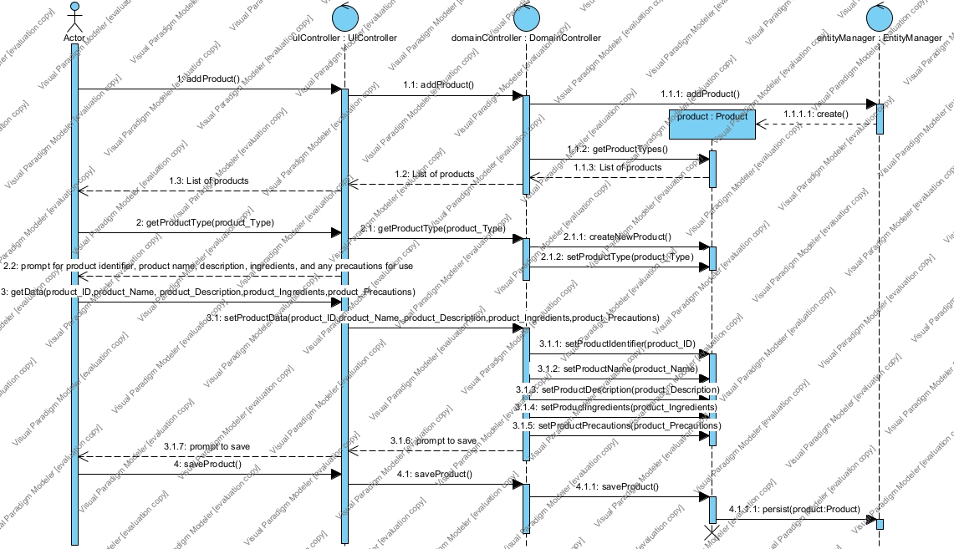

**Use Case: Maintain Purchase**

User Story

As the owner of this business, I would like to record my purchases so that I can quickly see how much money I’ve spent, what I’ve ordered and from where.

Acceptance Criteria:

1. Must be able to record purchases by supplier.
2. Differentiate between scheduled (bought online) and emergency purchases (bought in store).
3. Must be able to query purchases by product and by product type (example shampoo).

Use Case Descriptions

|  |  |  |  |
| --- | --- | --- | --- |
| Use Case Name | Add Items to Inventory | | |
| Triggering Event | Purchase of products, shipment has arrived (either pickup or shipped) | | |
| Brief Description | Allows the Owner to record new items to Inventory. | | |
| Actors | Owner | | |
| Related Use Cases |  | | |
| Preconditions | Owner has opened the Main Menu. | | |
| Post Conditions | Items are saved to the database and now can be queried. | | |
| Flow of activities | Actor | | System |
|  | 1. | Requests to add new inventory | Displays a list of suppliers and prompts for selection. |
|  | 2. | Selects a supplier. | Verifies that a supplier was selected. Prompts for purchase date and selection of receipt file location. |
|  | 3. | Enters purchase date and receipt file selected. | Verifies that date was entered and receipt selected.  Creates a unique identifier for the purchase. Prompts to enter product details. |
|  | loop | Chooses to add item | Displays a list of products and prompts for selection. Prompts for price, quantity ordered, and quantity received |
|  | 4. | Selects a product and enters price and quantities ordered and received. | Product must be selected.  Price and quantities must be entered  Data is valid  Extended price is calculated (price * quantity ordered)  Taxes are calculated and displayed  Purchase total is updated with the extended price + taxes  Purchase tax is updated with the tax amount  Displays purchase including totals, date and list of products.  Prompts to add another product |
|  | End | When all products selected | Displays purchase including totals, date and list of products.  Prompts to save purchase |
|  | 5. | Chooses to save | Saves the purchase and returns to the main menu |
| Exception Conditions | * Owner chooses to cancel adding the purchase | | |

**Sequence Diagram:**

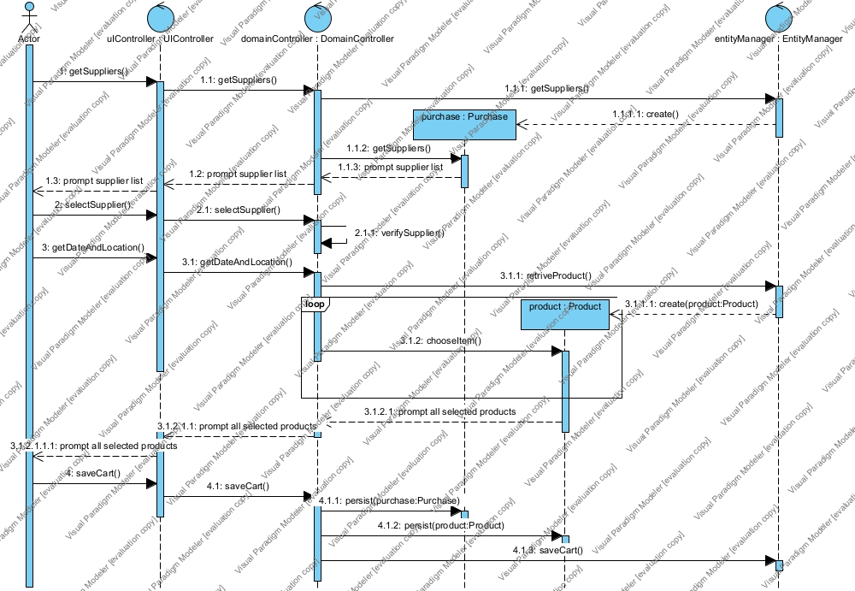

|  |  |  |  |
| --- | --- | --- | --- |
| Use Case Name | Query Purchases | | |
| Triggering Event | Owner requires a list of purchases for a date period listing Supplier, Products quantity purchased, price paid and the extended amount (price * quantity) | | |
| Brief Description | Allows the Owner to retrieve inventory items purchased for a specified date range | | |
| Actors | Owner | | |
| Related Use Cases |  | | |
| Preconditions | Owner has opened the Main Menu. | | |
| Post Conditions | purchases are retrieved, totaled and displayed | | |
| Flow of activities | Actor | | System |
|  |  | Requests to query purchase (by date) transactions | Displays a calendar |
|  |  | Selects date range | Verifies that dates are selected  Retrieves items purchased in the specified date range  Prompts to exit |
|  |  | Request to cancel | returns to the main menu |
| Exception Conditions |  | | |

**Sequence Diagram:**

